**Ideation Phase**

**Define the Problem Statements**

|  |  |
| --- | --- |
| Date | 11 May 2022 |
| Team ID | NM2023TMID12350 |
| Project Name | Project - xxx |
| Maximum Marks | 2 Marks |

**INTRODUCTION**

Now a days the home safety detection system plays the important role for the security of people.Since all the people from the home goes to work on daily bases, it makes impossible to check on the appliances available at home specially LPG gas cylinder, wired circuits, Etc. Since last three years there is a tremendous hike in the demands of liquefied petroleum gas (LPG) and natural gas. To meet this access amount of demand for energy and replace oil or coal due to their environmental disadvantage, LPG and natural gas are preferred.These gases are mostly used on large scale in industry, heating, home appliances and motor fuel. So as to track this leakage gas, the system includes MQ6 gas sensor. This sensor senses the amount of leak gas present in the surrounding atmosphere.Through this, explosion or getting affected by the leakage of gas could be avoided.

**OBJECTIVE**

The design of a sensor-based automatic gas leakage detector with an alert and control system has been proposed.This is anaffordable, less power using, lightweight, portable, safe, user friendly, efficient, multi featured and simple system device for detecting gas.Gas leakage detection will not only provide us with significance in the health department but it will also lead to raise our economy, because when gas leaks it not only contaminates the atmosphere, but also wastage of gases will hurt our economy. The need for ensuring safety in workplaces is expected to be the key driving force for the market over the coming years.

**PROBLEM FORMULATION**

Gas leakage is nothing but the leak of any gaseous molecule from a stove, or a pipeline, or cylinder etc. This can occur either purposefully or even unintendedly. As we are aware that these kinds of leaks are dangerous to our health, and when it becomes explosive it could cause great danger to the people, home, workplace, industry and the environment.

Few of the major incidents that took place due to gas leakage include the Bhopal Disaster and the Vizag Gas leak. The Bhopal disaster is known to be the worst industrial accident ever. Approximately 45 tons of Methyl Isocyanate was leaked from this insecticide plant. Methyl Isocyanate is an organic compound and a chemical that could come from the carbamate pesticides. This colorless, poisonous and flammable liquid is something that human beings have to be away from.

Vizag Gas leak was a resultant of the escape of styrene that were unattended for a long period. This colorless oily liquid can spread in fumes. So, a detector must be made in such a way that could detect any kind of gas, fume, leak, smoke etc. However harmful and dangerous it can be, the detector could be attached with certain parameters that could help to prevent the issue.

**PROPOSED METHODOLOGY**

Our device consists of three main parts.

1. Detection System

This part consists of a gas sensor MQ5 and this will continuously monitor the gas concentration.

1. Prevention System

This part consists of a special type of Gas valve that we will be designing that will be similar to present regular valves but a servo motor will be attached to its control knob to allow automatic and as well as manual control. A connection to the exhaust fan and window is made, in which the sensor would make it run in case of gas detection. All these parts will be interfaced with Arduino Uno which will be controlling the whole device.

1. Alerting System

It consists of a GSM modem to send an Alert message to the user via SMS. Also, we attach a section that would make call to the user upon detection.

**LIST OF COMPONENTS**

|  |  |  |
| --- | --- | --- |
| S. No | Name of the component | Quantity |
| 1 | Arduino board | 1 |
| 2 | MQ-5 LPG CNG Sensor | 1 |
| 3 | Servo Motor | 1 |
| 4 | Breadboard | 1 |
| 5 | Relay | 1 |
| 6 | GSM Module | 1 |
| 7 | LED display | 1 |
| 8 | Stepper Motor | 1 |
| 9 | LCD Display | 1 |
| 10 | Arduino uno cable | 1 |
| 11 | Jumper wires | 1 |
| 12 | Buzzer | 1 |

**KEY PARTS**

1. Arduino

It is a microcontroller developed by Arduino.cc which is equipped with pins of both analog and digital type. This board can be encoded using the Arduino IDE software. It comes in various types, in which here we have used Arduino Uno. It would receive the signal upon detection of gas and performs the command to turn the knob off, opening of the windows and indicating via LED.

1. MQ5 Gas Sensor

The term ‘MQ’ comes from the Chinese word Mingan meaning sensitive and Qi lai meaning gas.

As the name suggests, it senses the gas, smoke, fume etc. It detects by allowing the gas to pass through the electrode having membrane. Then, it creates current flow as the gas gets oxidised. The current is responsible for determining the type of gas.

1. Buzzer

This electromechanical device is used for audio signalling. This can be accessed via timers or alarming or by the confirmation of the user. Here, the mechanism used is to alert the user upon the detection of the gas

1. Knob

The automatic knob is considered as the prevention for gas leakage. After the Arduino board sends the signal to the software, the command is passed to turn off the knob with the help of a servo motor.

1. Window

The window automatically opens to avoid suffocation and to allow outside air to fill the space. The mechanism over here is similar to the knob, where the command is passed from the software and it opens upon detection.

**CIRCUIT DIAGRAM**

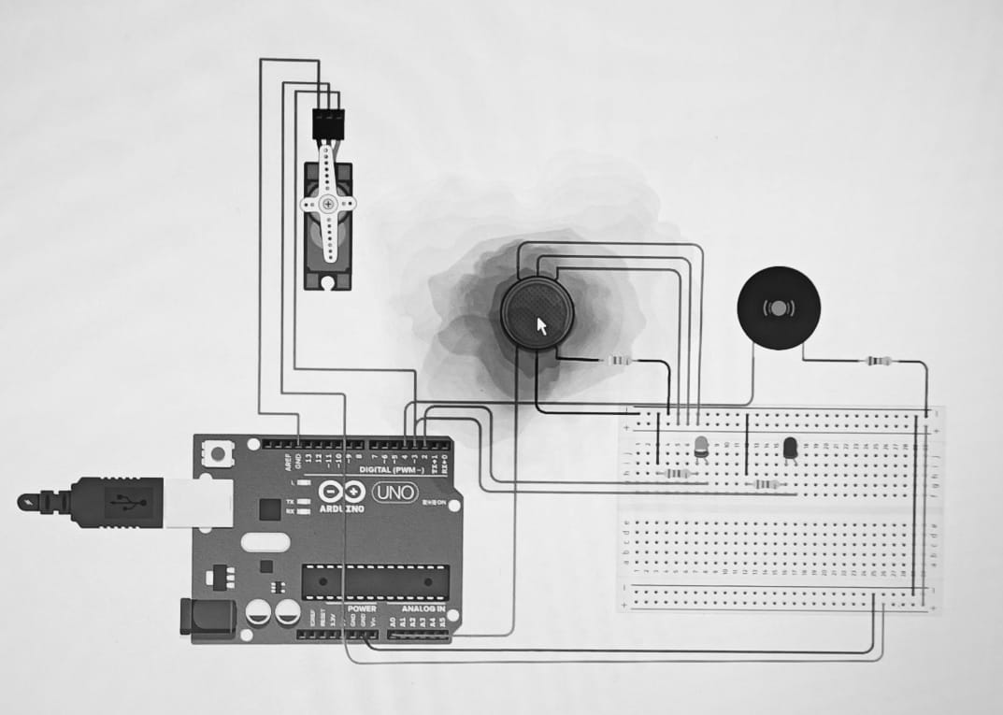

**Results**

As intended, the MQ5 sensor does detect the gas and lets the Arduino know. The Arduino board efficiently sends the signal to the software. As we have programmed in the software, it does run the program and hence the output is seen as the buzzer sound is heard, the window opens via the servo motor.Hence, the harmful gas, smoke and fumes can be distinguished by this detector, alerted to the user, prevented from danger and achievean environment-friendly surrounding.

**FUTURE SCOPE**

Over the years, we have been marching towards various developments and advancements. This includes smart houses artificial intelligence etc. Smart houses can make our in-room living simple as much as it can. The control of fans and lights is now within our hands. Wi-Fi and software programming has put forth the initial steps towards the future to make control over the safety and other applications in the house. Another innovation that could push it a little further would be this gas detection sensor. As it ensures safety in our house from the gaseous hazards. Also, in industries and factories, we can avoid the disaster and ensure the safety of the workers.

**CONCLUSION**

Thus, we would like to conclude that our system mainly focuses on home and industrial safety. By this,provides us with significance in the health department. Also, it leads to raise our economy, because when gas leaks it not only contaminates the atmosphere, but also wastage of gases will hurt our economy. Moreover, when the workers get affected, the job in the industry or factory cannot be continued, hence, affecting the economy. The need for ensuring safety in workplaces is expected to be the key driving force for the market over the coming years. Therefore, this detector solely can prevent and ensure safety.